**Attribute Listing**

Creativity is defined as the habit to generate useful ideas, and alternatives, to solve problems, and re-engineer products and services useful to the stakeholders. Thus, we require various creativity techniques which should enable us to generate useful and new ideas.

By and large creativity tools enable us to think divergently and out of box. The creativity techniques can be grouped in divergence and convergence techniques, product and service situations, individual and group techniques.

Some of the divergence creativity techniques are attribute listing, biomimicry, brainwriting 6-3-5, osborn checklist, reverse brainstorming, etc.

In this we will discuss about attribute listing which is one of the

divergence creativity technique. What is Attribute Listing?

In 1931 Robert Platt Crawford

pioneered/ used attribute listing in his course on creative thinking.

Attribute Listing is suitable for situations which can be decomposed into attributes.

The technique takes an idea from one thing and applies it to another.

As defined by Crawford

“Each time we take a step we do it by changing an attribute or a quality of something else, or else by applying the same quality to some other thing.

The pattern of great pieces of creation may involve hundreds of successive changes.

The creative step is the same, but it is repeated many times with many variations.”

Often it is observed that we have preconceived ideas about a particular situation or people. This limits our thinking as our mind is pre-conditioned to certain standard expectations and characteristics related to that particular situation or person

For example, if we have a meeting with a CEO of a big Company, by

default we expect the CEO to come in a luxury car. While we wait at the entrance to welcome the CEO to come in a luxury car instead we find a person coming in a motorbike who is none other than the CEO. In this situation our mind is pre-conditioned to expect that a CEO is attributed to luxury cars. In attribute listening, we have to question "normal"

characteristics.

Attribute listing is a creative technique that can assist you to expand and diversify your product and service range. While using the technique of attribute listing we break a problem down into smaller and smaller parts or attributes and look at alternative solutions to these parts. The technique lets you focus on as many attributes of a product or problem as possible with different perspectives like physical attributes, social attributes, process attributes, psychological attributes and financial attributes.

Steps of attribute listing

Step 1 : Identify a product, or process which you want to improve

. For example if you want to improve learners’ helpdesk.

Step 2 : List its attributes by breaking it into key attributes or stages or sections. For example, attributes of a learner helpdesk includes opening hours, learner friendly services, availability information material on various programmes, etc.

Step 3 : Choose the attributes which are important and improvement in

them may lead to improvement in the entire process or product.

Look at each attribute individually and identify variations so that it can be improved. For example, look for alternative solutions for better serving the learners as per their timings. Like decide the opening and closing hours in weekdays and weekends depending on the learners’ convenience, keeping record of visitors, their feedback about the services provided and following up and so on

Step 4 : Combine one or more of these alternative ways of improving the identified attribute and look if you have come up with some improved process or product.

Attribute listing is one of the quick creativity techniques which when

performed in small groups results in diverse combination of interesting ideas which provide solution to a tangible problem.

Attribute listing is a technique from the early 1930's which

takes an existing product or system,

breaks it into parts,

identifies various ways of achieving each part, and then

recombines these to identify new forms of the product or system.

It has many variants, and is an important precursor to techniques such as Morphological Analysis and Value Engineering.

A new kind of project management method probably has much the same major functional elements as any other kind project management method, but with some important difference in the way the elements are achieved or put together. So to generate a new way of doing something, you could list all the key attributes of current approaches, and try to improve on some of them. So:

Identify the product or process you are dissatisfied with or wish to improve.

List its attributes. For a simple physical object like a pen, this might include: Material, Shape, Target market, Colours, Textures, etc.

Choose, say, 7-8 of these attributes that seem particularly interesting or important.

Identify alternative ways to achieve each attribute (e.g. different shapes: cylindrical cubic, multi-faceted….), either by conventional enquiry, or via any idea-generating technique.

Combine one or more of these alternative ways of achieving the required attributes, and see if you can come up with a new approach to the product or process you were working on.

Unfortunately, classic Attribute Listing offered no advice about the ‘combinatorial explosion’ that occurs as the number of attributes and alternatives increases. If you have N attributes and each could be achieved in M alternative ways, there are MN combinations – so even with only 5 attributes, each with only 4 alternatives, you already have over 1000 logically different combinations! The designer is left to explore different possible combinations using imagination and intuition.

Using randomly chosen combinations to stimulate ideas: If you prefer a more mechanical and less intuitive way of using this array of alternatives, you could generate provocative combinations by working through each attribute in turn and picking one of the ways of achieving that attribute at random (e.g. with dice). You can then use this either as a random stimulus to trigger more ideas (cf. Random Stimuli) or you can attempt a form of constructive evaluation by identifying what would be good about it, and what problems it would create (e.g. Plusses, potentials and concerns, or Receptivity to ideas). This process of generating random combinations and then using them to stimulate ideas can be repeated ad lib.

The combinatorial problem is explored more fully in later developments such as Morphological Analysis.

Attribute Listing is a creative technique which involves breaking the problem into smaller and smaller parts and looking at alternative solutions to these parts.

Attribute Listing is a good tool for Incremental Innovations in a product/service. This tool is generally combined with other creativity tools like Reversal Technique, Analogical Reasoning, SCAMPER, Word PO etc…

A customer’s Value Proposition is Greatly improved by the addition of many minor innovations, yielding a massive competitive advantage.

Imagine designing a pen. The pen has following parts such as Nib, Cap, Tip, Barrel, Refill, Grip, Dip. Other than these part attributes, we can consider other attributes like shape, length, colour, printing, and used for writing. Focus on one attribute at a time and look for alternatives. Example- Shape, Can we change the circular shape to triangular?

When you subdivide the challenge/problem into many separate parts, the challenge does not change, but your perception of it does and leads to new ideas — Michael Michalko

Attributes can be classified into subcategories like

Physical attributes: shape, form, colour, texture, structure, sound, taste, door, space, density, location

Social attributes: responsibilities, taboos, power, ecological

Process attributes: selling, marketing, production, manufacturing, designing

Psychological attributes: needs, motivation, positive and negative emotions

Price attributes: production cost, consumer price, Consumer acquisition cost, manufacturing cost, sunk cost

Let’s look at an example that you want to start a Restaurant and need to come out with few ideas. Bear in mind that this is an exercise to show how to use this creativity tool, so it will not have deeper analysis or Judging Criteria for selection of ideas. Some of the ideas shown below may not be practical/relevant due to my limited knowledge on Food Varieties, Nutritional Values, Taste sensations, Restaurant limitations etc… Professional knowledge would lend a hand to come out with better ideas. Knowledge is the foundation of creativity.

Being a designer, we are biased towards real users. Therefore, I’m listing down attributes which a User feels important. As a user, I may not be interested in attributes like investment requirements, problems with hiring manpower(Though they are major factors from an investor’s perspective).

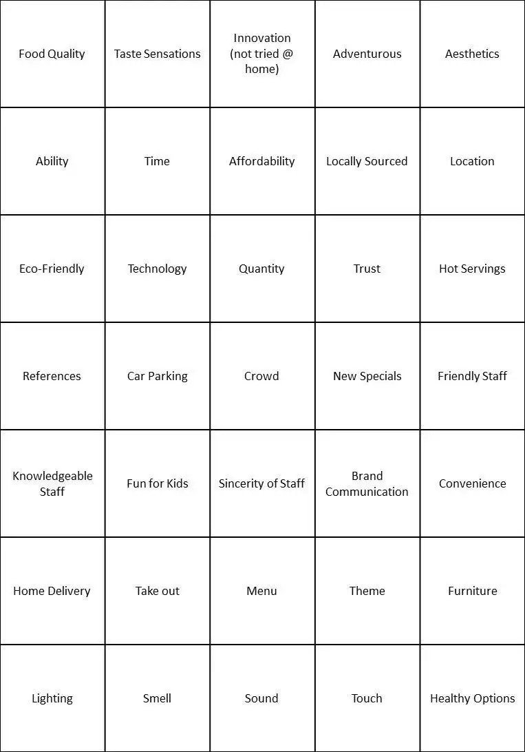

Please note that some of the attributes are interlinked. When we generate ideas for a Theme attribute, it would cover attributes like Lighting, Sound, Touch, and Furniture.

Let’s take some FOUR attributes and look for alternative ideas

ATTRIBUTE 01 — FOOD QUALITY

Food Quality — External and Internal Characteristics that are acceptable to Consumers. Taste is one of the main internal factors, which should be different, and difficult to be replicated in the home. We have kept this as a separate attribute. Then, Can we look at external characteristics(Appearance — Shape, Form, Size etc…) of Food Quality?

How to visually Communicate Quality of Food?

Handcrafted, Workmanship

How about a Transparent and Fine Detailed plate of an Organic shape

How about Edible Diamonds in the food

How about serving in Delicate, Fragile Utensils

ATTRIBUTE 02 — INNOVATION in FOOD

SCAMPER is a relevant Creativity Technique to help in generating Ideas for Food Innovation.

S-Substitute, C-Combine, A-Adapt, M-Modify/Magnify, P-Put to a different use, E-Eliminate, R-Rearrange.

Assume, we are looking for Innovations in South Indian Food, IDLY. Let’s use C-Combine word for generating ideas.

IDLI like a bar chocolate with Nuts and Seeds? Stuffed IDLI? IDLI Burger? IDLY+YOGURT+HONEY+Food on the GO? Half-Colored/Half different textured IDLY? Doughnut IDLY? IDLY Sandwich? IDLY+YOGURT+HONEY+Food on the GO?

ATTRIBUTE 03 — THEME for RESTAURANT

Imagine we have chosen a theme of “Excitement”. Let’s generate ideas for the same.

Exciting — Hot Experience — Hot — Fiery — How about objects are on fire inside the restaurant? All food served hotter. The environment is also very hot due to raging fire.

How about a Desert Theme with sand dunes

Exciting — How about a hanging bridge between two walls and dine in the swaying bridge

Exciting — Delicate -Softness — Can we sit among cushions of flowers and Dine?

Exciting — Adventure — Wall Climbing — Can we ask consumers climb the wall to reach dining place? — A Healthy Option

Exciting — Thrill — Can the floor be of sharp rocks — People have to jump and walk, extremely cautious? Sit on rocks and Dine?

Exciting — Travel — Chilly — How about a Restaurant full of artificial snow?

ATTRIBUTE 04 — MENU

Let’s assume that we have chosen Rocky Terrain as our Theme. How can the menu be?

Rocks — Hammer to Break — Booklet in the shape of Hammer

Quartz Crystals — Bunch of Crystals — Each Crystal is printed with a food name?

Menu printed on a wooden log?

Menu inscribed on a stone?

The more we divide the challenge, the more attributes we can improve. By separating one attribute, we are able to improve focus, think flexibly and discover alternative ideas. Sometimes, Grouping of related attributes may inspire ideas.